- Always trouble
- One faction enforces thier laws?
- Main focus: imerse the player
- make moral choices feel impactfull
- Stereo typical bandits, middle eastger vibe doe (runts(physically smaller, looked down on), )
- nature god scene - magestic animals frolocking around, not to obvious though boss shifts thrrouight fazes, or maybe juist ghas different zones maybe its just brewanda motrphing potentially
- Different facetions, bosses, optional faction quests compelling charecter, warring amongst them,sdelves for resources and t6erritory, power struggle.
- C'thun Spooky shit.
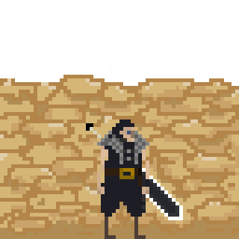
- Dragon fight, tower, fight m nions and occasionallky hit hand or head or wing
- subtle death bossfight
- Middle eastern
- Post apocolypse
- Reclaimed by nature
- Extreme Biomes -
Desert (bad lands madmax shit)
City Ruins
Overgrowth zone (Wildlife reclaimed some cityscape)
Swamp zone
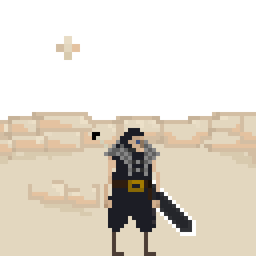
- Sandy
- Science and alchemy
- market stalls
- desolate city
- Living in reclaim ed ruins

